AWS Task-4

Launch an EC2 instance (Linux and Windows) along with a web server. Then, create an EBS volume of 5 GB, attach it to an EC2 machine (Linux and Windows), and take a snapshot. Finally, create an EBS volume using the taken snapshot.

Linux Machine :

Volume created with 5 GB and attached to Linux EC2 instance as below,

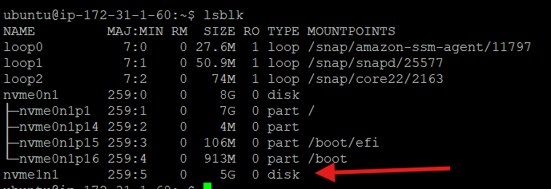

Partitioned attached volume as below,

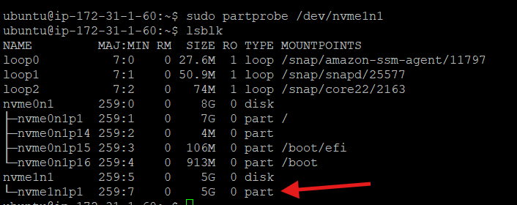

Mounted with Linux EC2
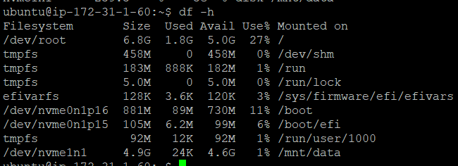

Windows Instance :

Created 5 gb volume and attached to Windows instance

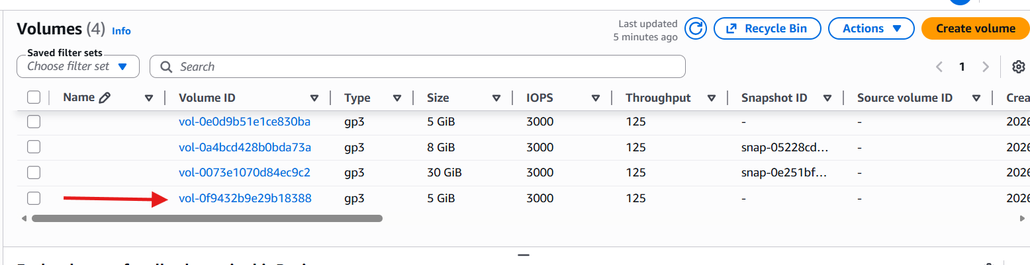

But As of now showing C drive alone with 30 GB

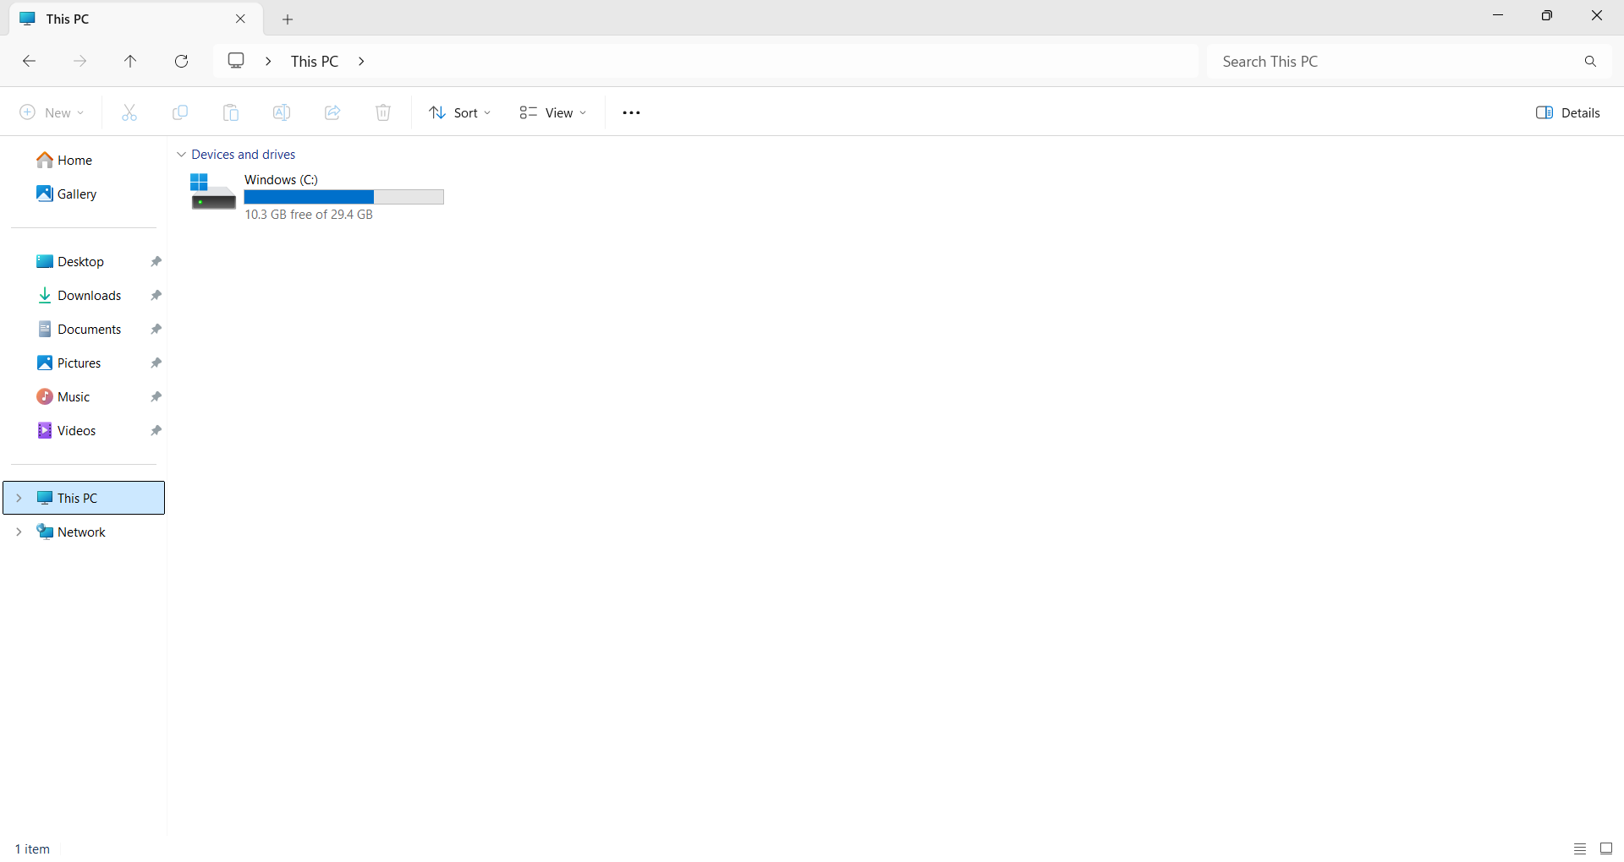

From Disk Management, made added disk into Online as below,

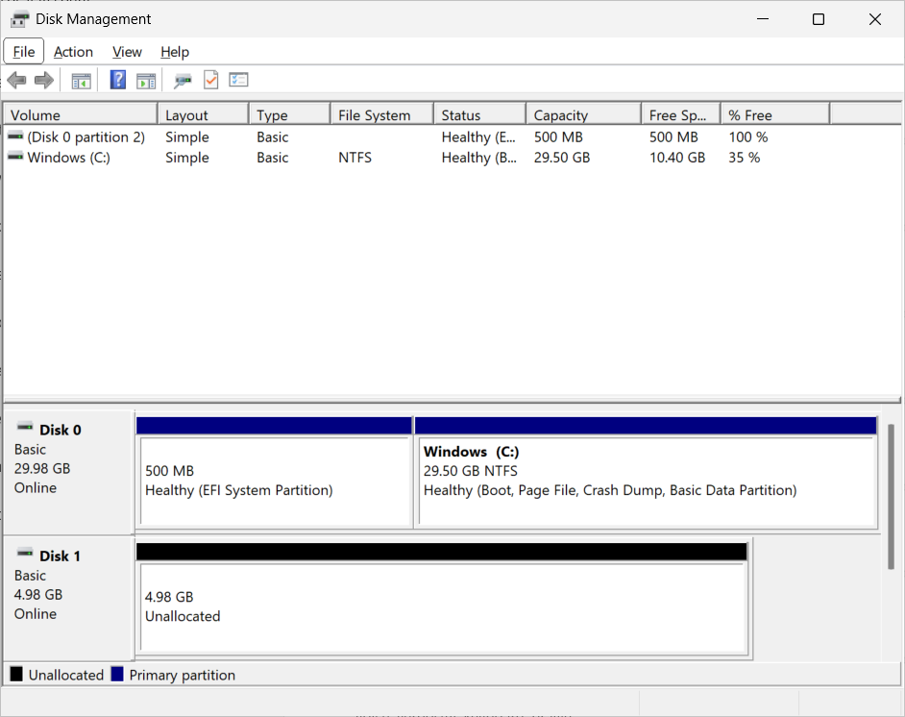
Now 5 gb id mounted and partitioned with another drive ( D: Drive ) as shown below,

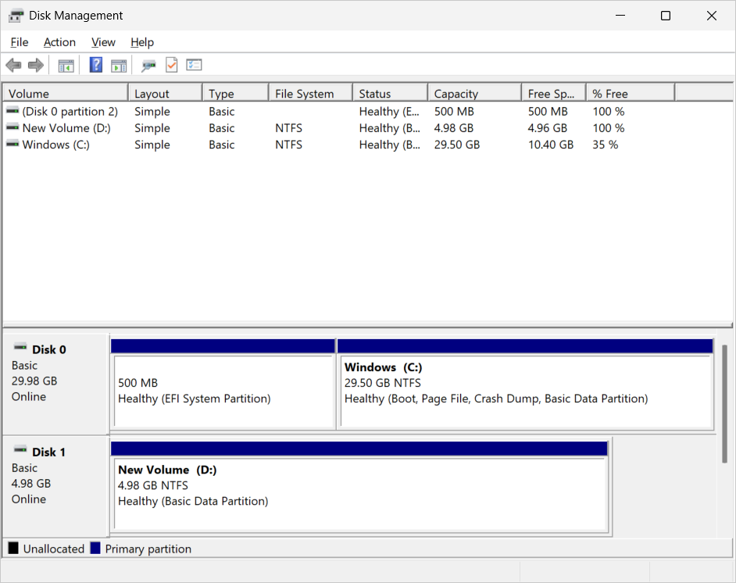

Created Snapshot from already created volume,

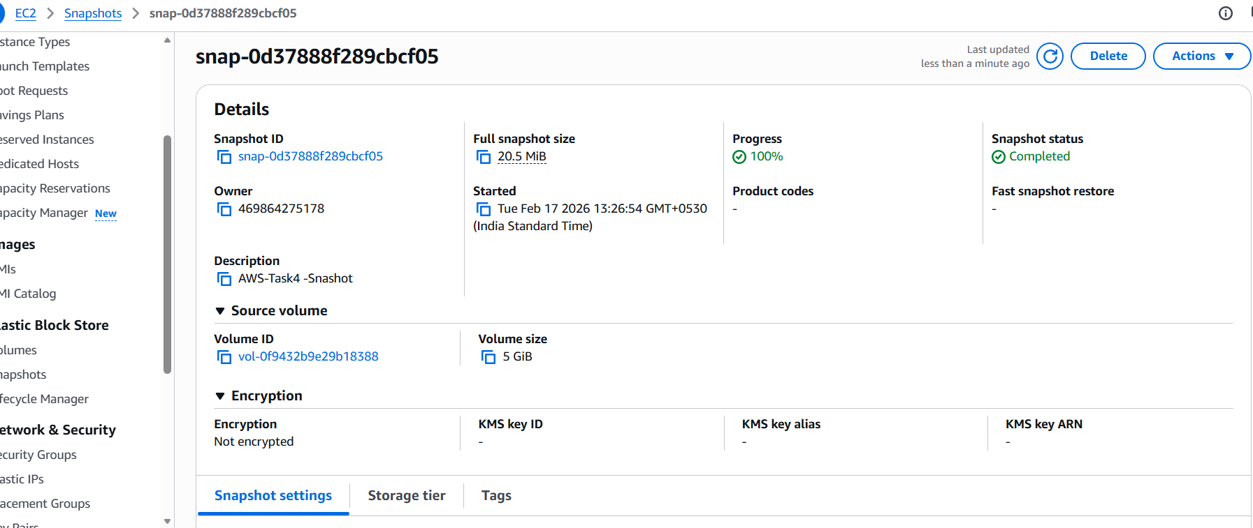

Creating volume from the above snapshot,

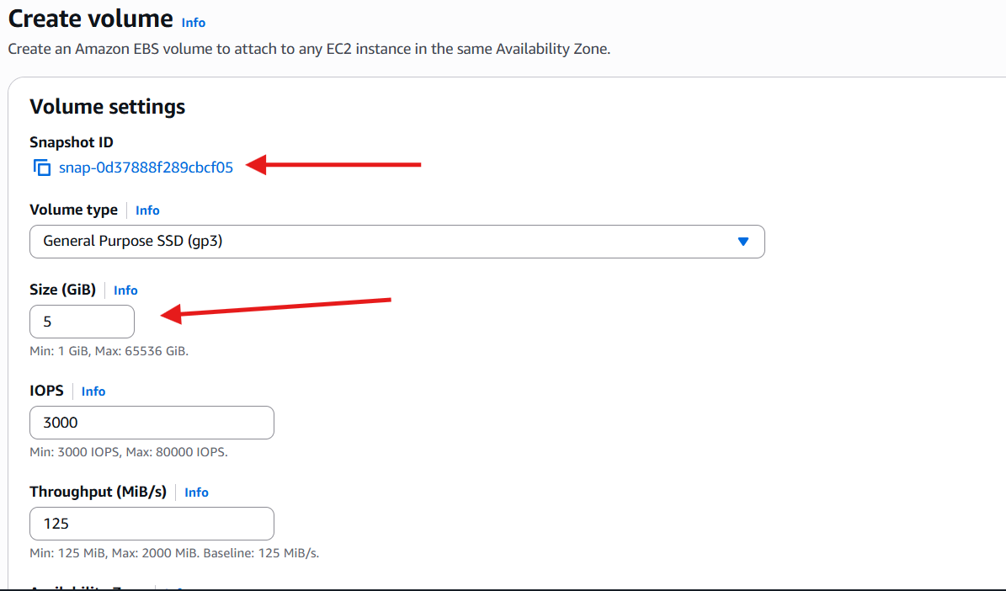

Created Volume with Snapshot:
